ECE 724 Assignment Technical Report

Guangmin Qu
Department of Electrical & Computer Engineering
McMaster University
Hamilton, Canada
qug4@mcmaster.ca

INTRODUCTION
This assignment aims to model the electrical vehicle (EV) to predict the performance in real road conditions. The model of the EV is the 2015 Chevrolet Spark EV, and the dynamometer test result of the EV is provided from Argonne National Laboratory Downloadable Dynamometer Database.
In order to more realistically measure the results of EV driving in the real environment, various driv cycles are combined in this experiment.
The method of modelling the EV is Using simulation software MATLAB/Simulink, and the result of the modelling will be compared with the dynamometer. The drive cycles data will input into the EV model; after serious computation, the result will be output, such as the simulated battery state-of-charge (SOC).

MODEL OVERVIEW
In general, the EV model includes three main subsystems: the driver module, the controller module, and the vehicle module. Besides these three subsystems, the model needs a clock block to count the simulation operating time; a memory block to store and delay the feedback data; an input block to deliver the drive cycle data.
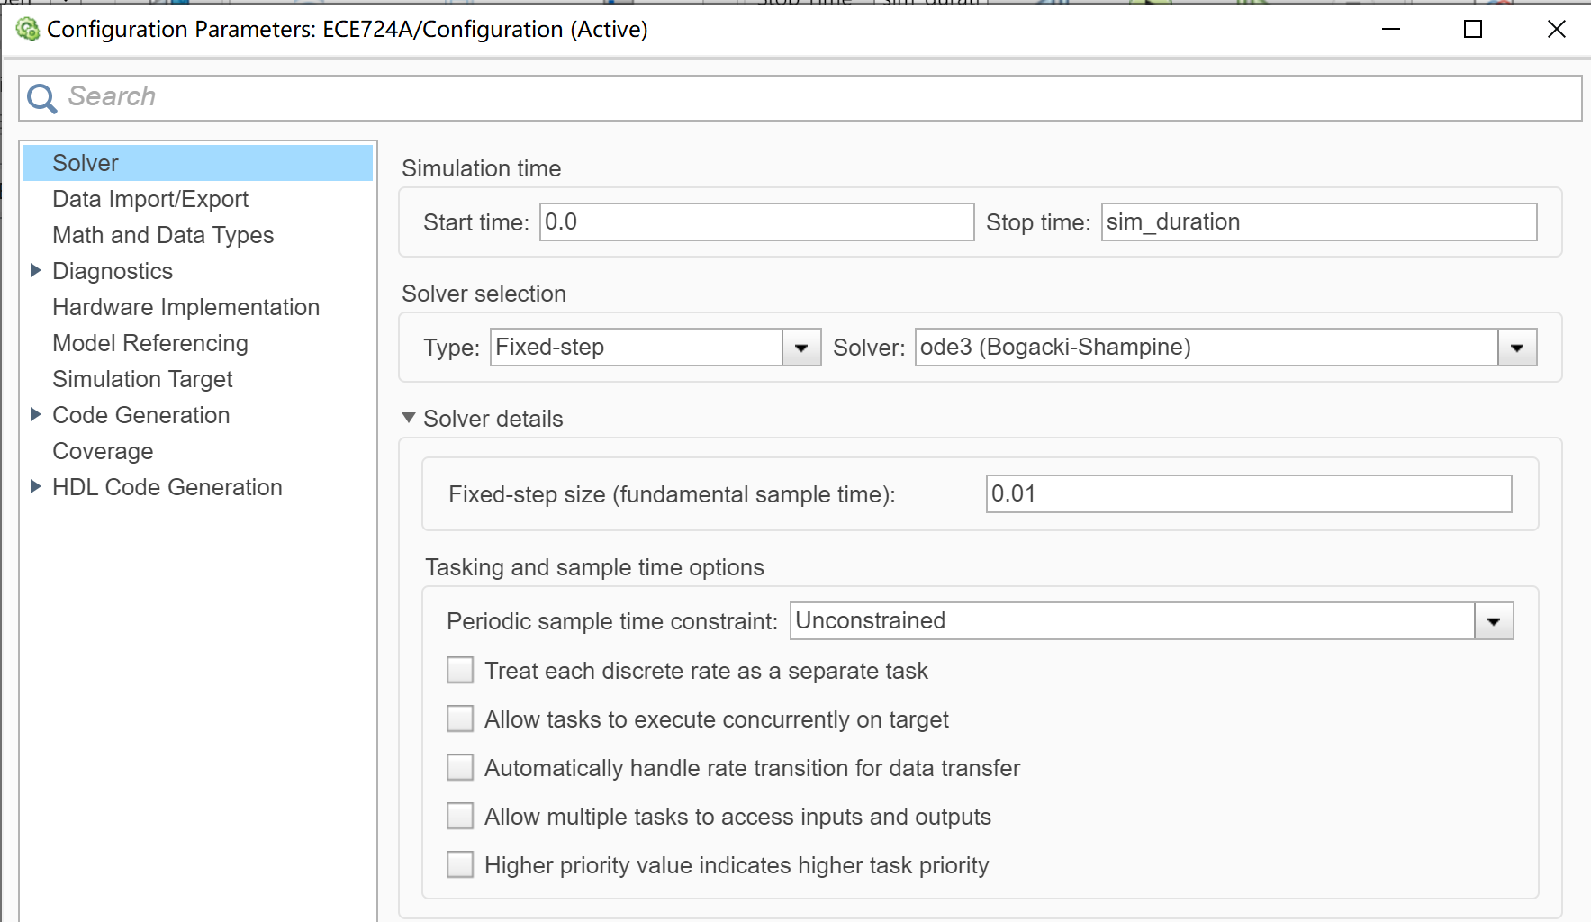
Figure 1. Clock counts time until stop time is reached
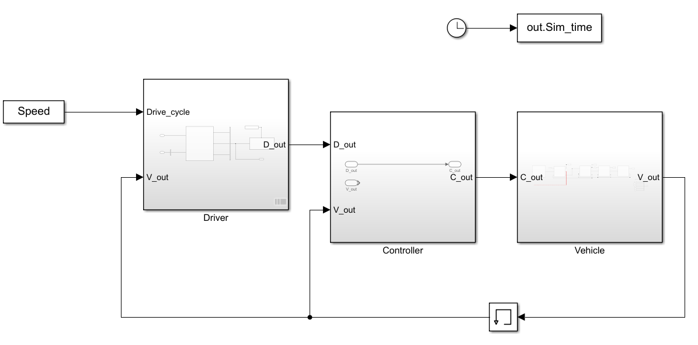
Figure 2. Model overview

results
 | Value
Vehicle_weight | 1300
Wheel_radius | 0.292
SOC_min | 0.05
f_d | 3.87
Base_power | 300
columbeff | 0.98
g | 9.8
gear_efficiency | 0.96
J_fd | 1
J_motor | 1
J_wheel | 1
Init_capacity | 54
r_mass | 0.64
SOC_min | 0.05
Stop_speed | 0.01
Table 1. General parameters
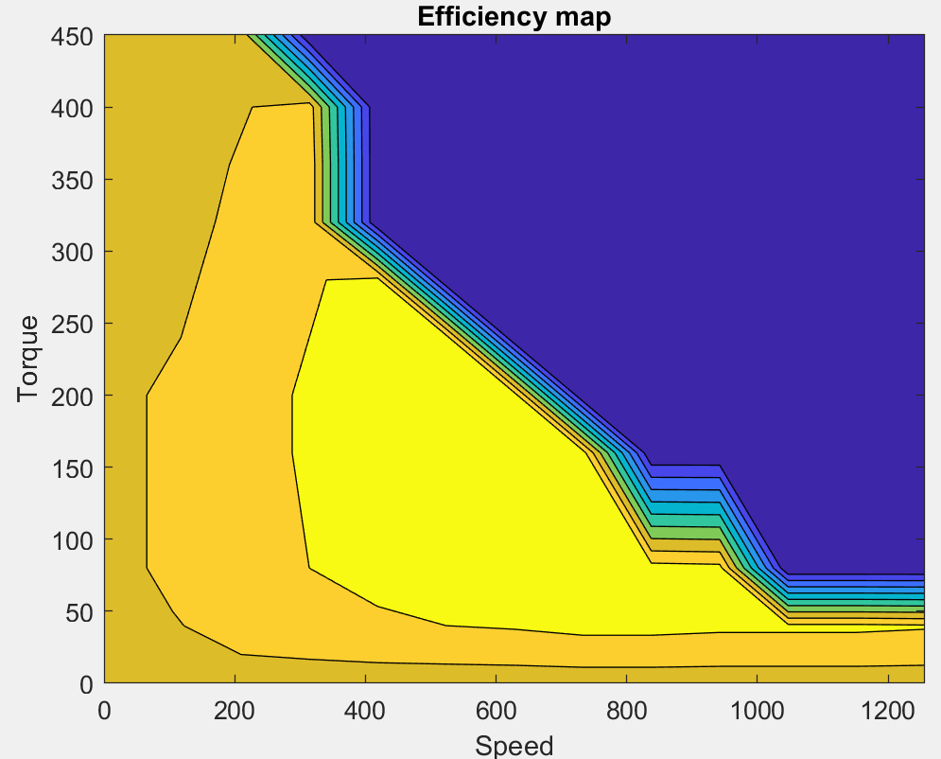
Figure 3. The efficiency map of the motor
 | Battery Voltage RMSE | Battery Current RMSE | Battery SOC RMSE
61508010 | 6.17 | 78.07 | 1.78
61508013 | 6.96 | 18.24 | 1.53
61508014 | 11.83 | 41.29 | 9.26
61508015 | 6.38 | 10.43 | 5.16
Average RMSE  across 4 cycles | 7.84 | 37 | 4.43
Table 2. RMSE results

 | Spark energy use | Sim energy use | Difference
61508010 | 6444777.76 | 7976074 | 80.8%
61508013 | 22769874.72 | 32322368.57 | 70.45%
61508014 | 14675933 | 26094025 | 56.24%
61508015 | 15478408 | 20515226 | 75.44%
Table 3. energy use

61508010
 | Value
SOC_init | 0.3058
sim_duration | 254
Grade | 6°
Table 4. 61508010 parameters
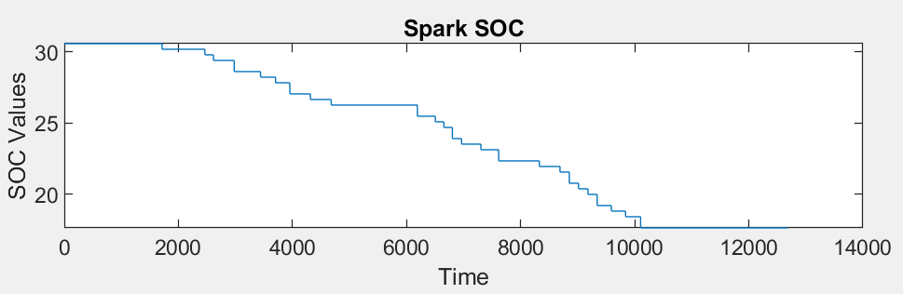
Figure 4. Spark test SOC result
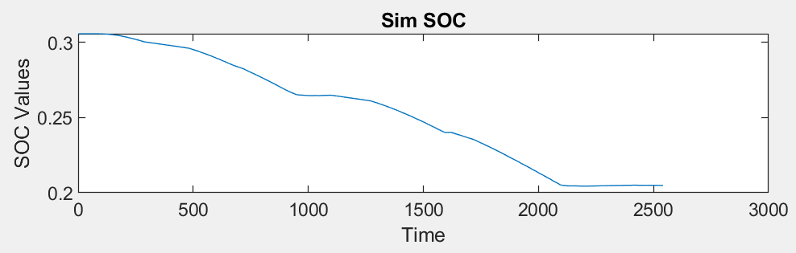
Figure 5. Simulate SOC result
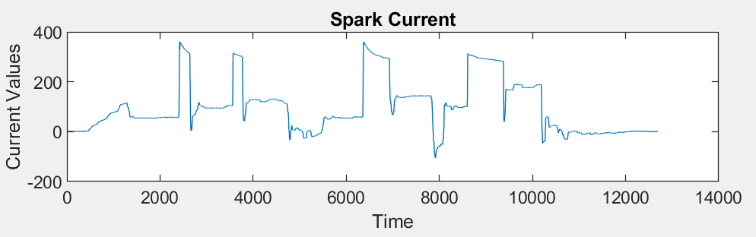
Figure 6. Spark test current result
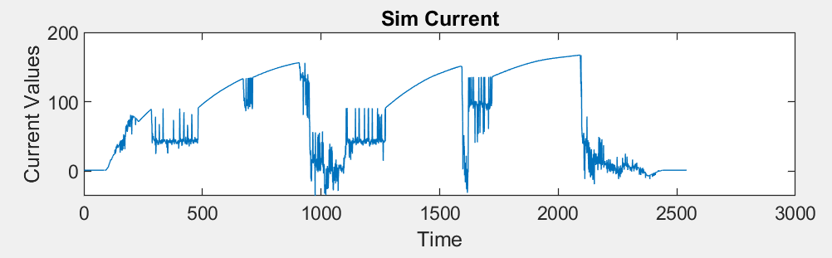
Figure 7. Simulate current result
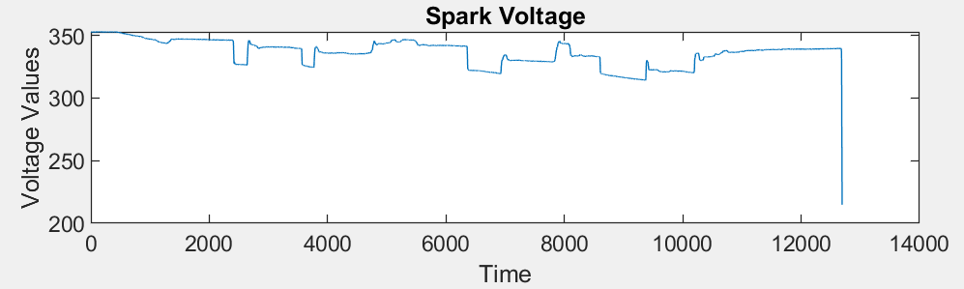
Figure 8. Spark test voltage result
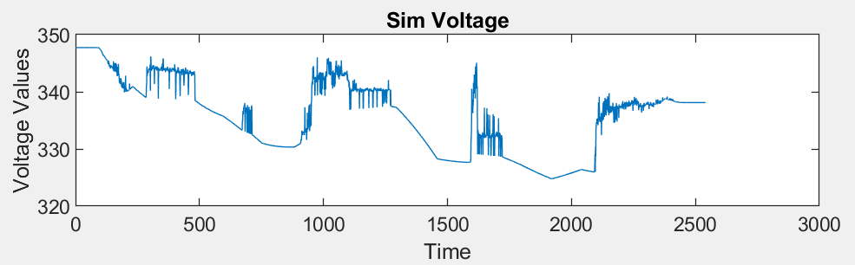
Figure 9. Simulate voltage result

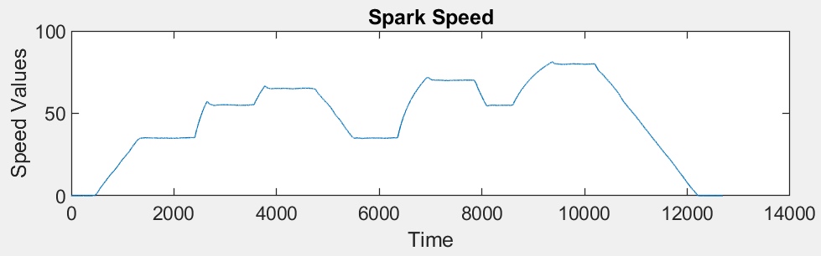
Figure 10. Spark test voltage result
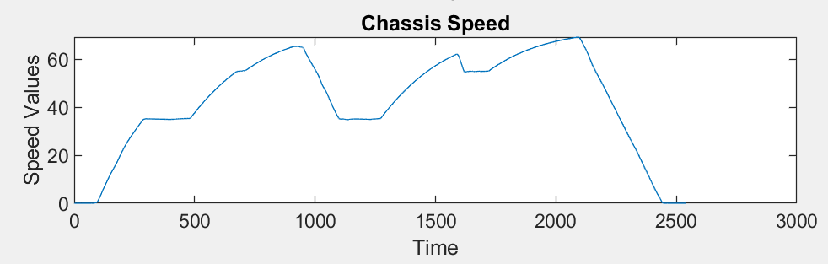
Figure 11. Simulate speed result

61508013
 | Value
SOC_init | 0.9996
sim_duration | 4253
Grade | 0°
Table 5. 61508013 parameters
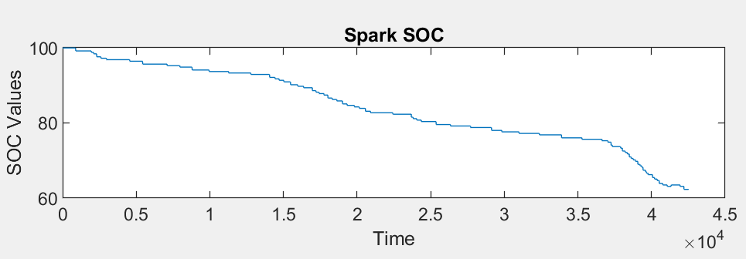
Figure 12. Spark test SOC result
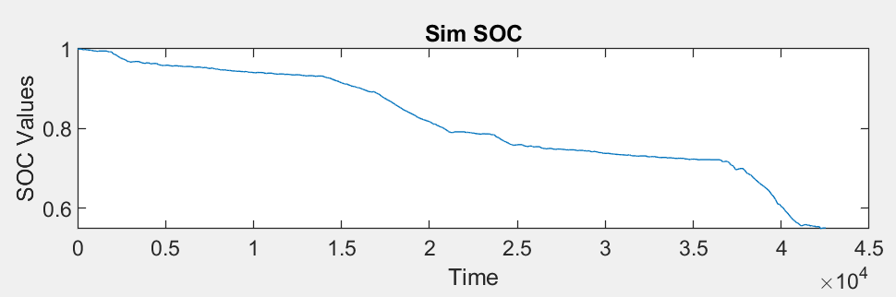
Figure 13. Simulate SOC result
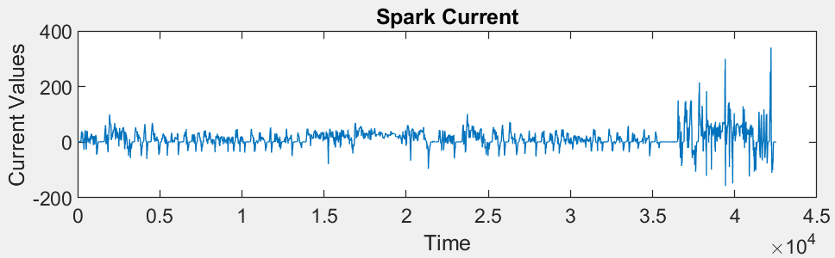
Figure 14. Spark test current result
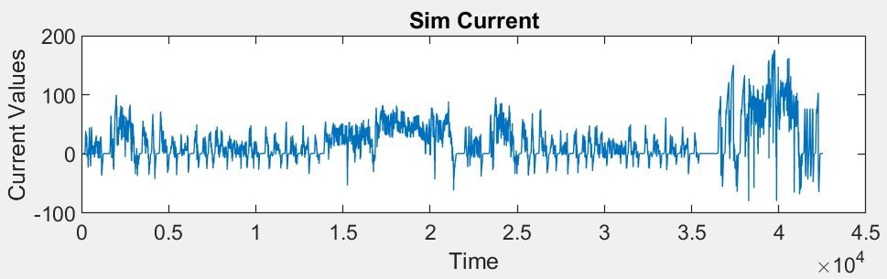
Figure 15. Simulate current result
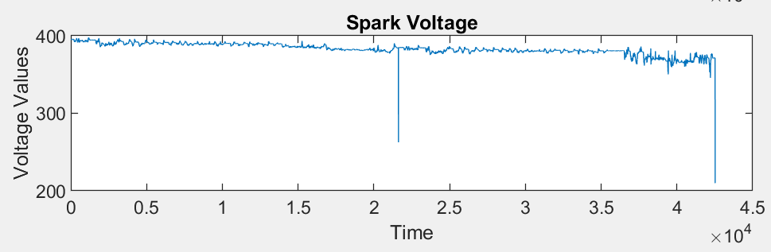
Figure 16. Spark test voltage result

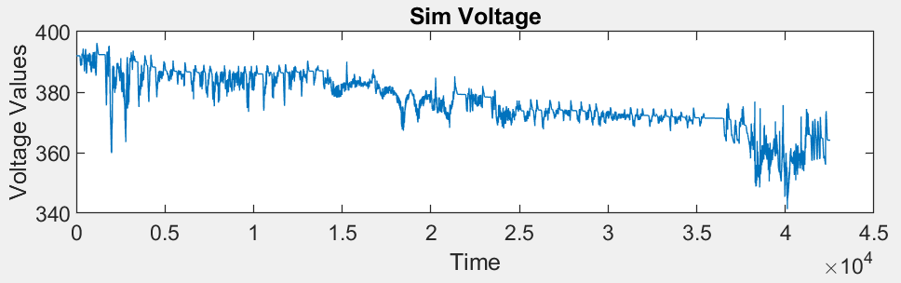
Figure 17. Simulate voltage result
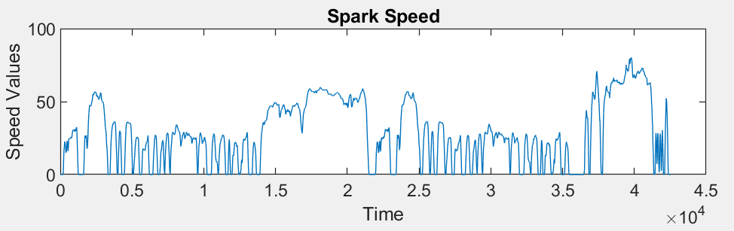
Figure 18. Spark test speed result
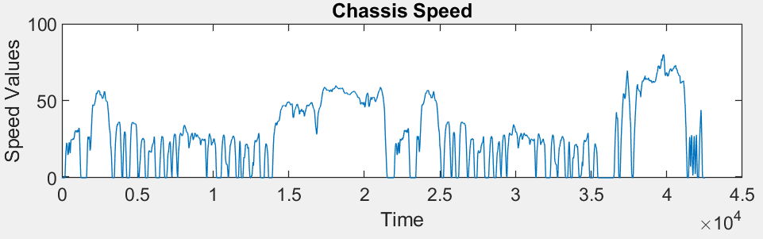
Figure 19. Simulate speed result

61508014
 | Value
SOC_init | 0.6233
sim_duration | 1246
Grade | 0°
Table 6. 61508014 parameters

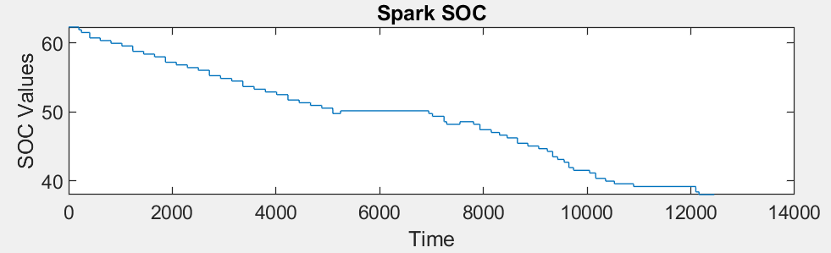
Figure 20. Spark test SOC result
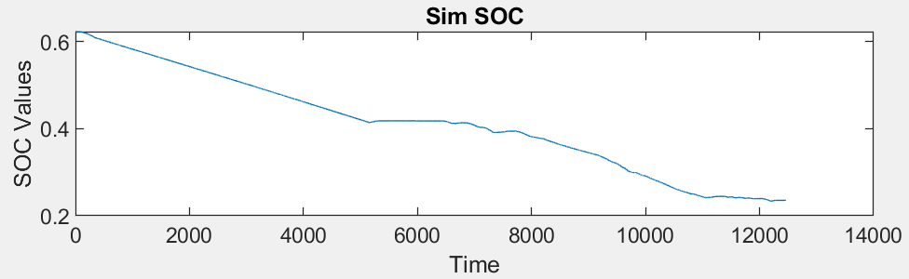
Figure 21. Simulate SOC result
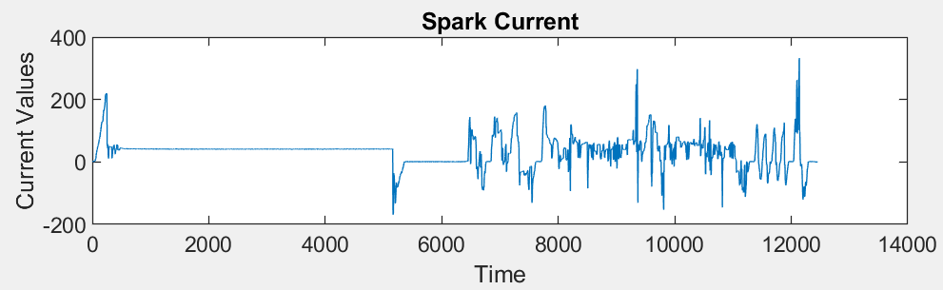
Figure 22. Spark test current result
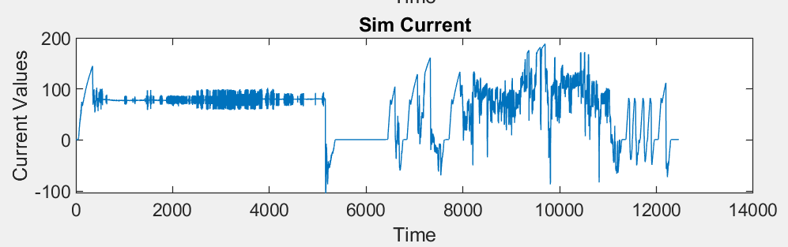
Figure 23. Simulate current result
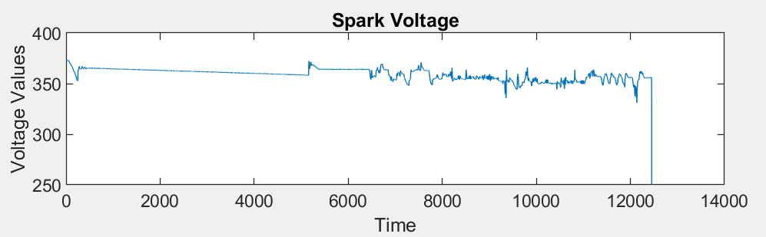
Figure 24. Spark test voltage result
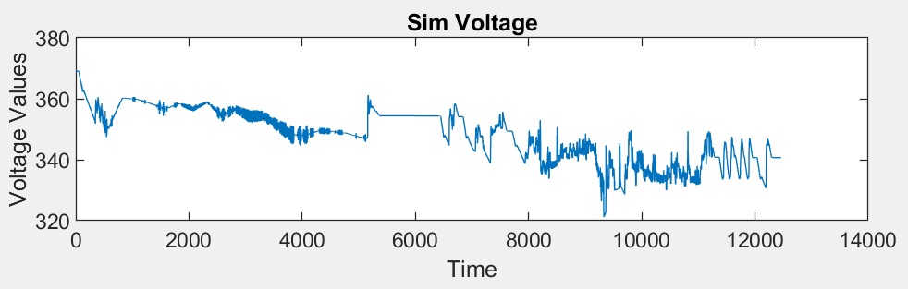
Figure 25. Simulate voltage result
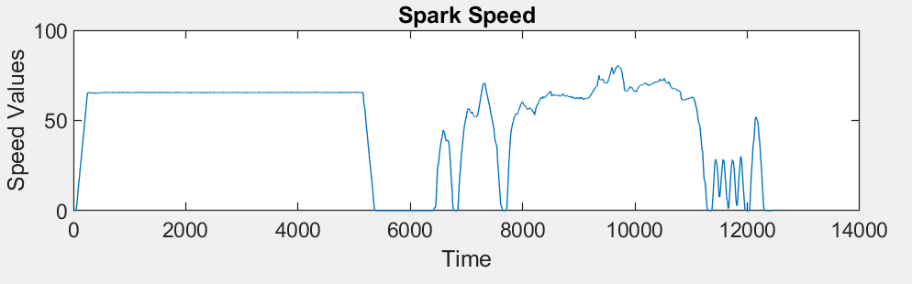
Figure 26. Spark test speed result
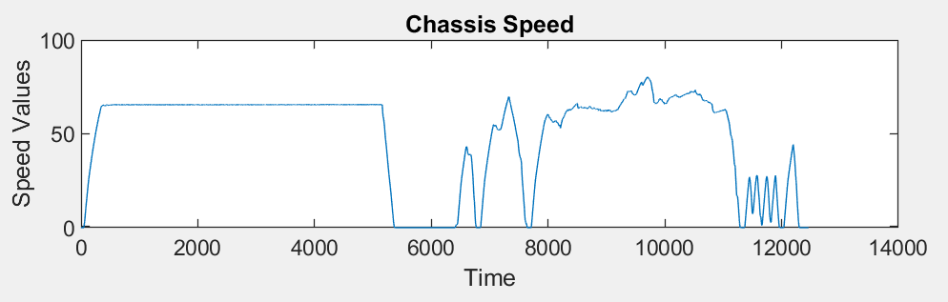
Figure 27. Simulate speed result

61508015
 | Value
SOC_init | 0.3802
sim_duration | 3559
Grade | 0°
Table 7. 61508015 parameters

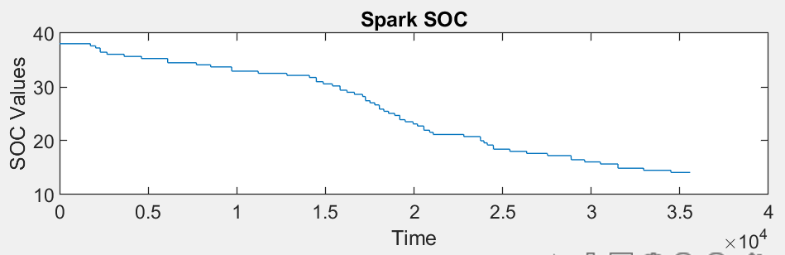
Figure 28. Spark test SOC result
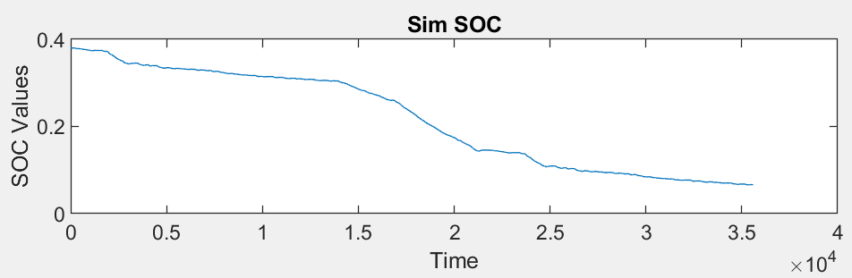
Figure 29. Simulate SOC result
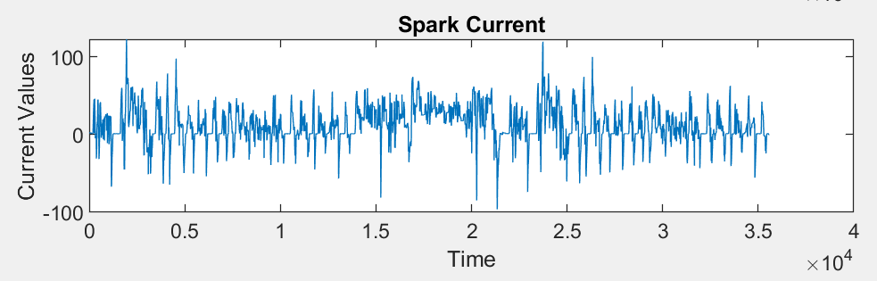
Figure 30. Spark test current result
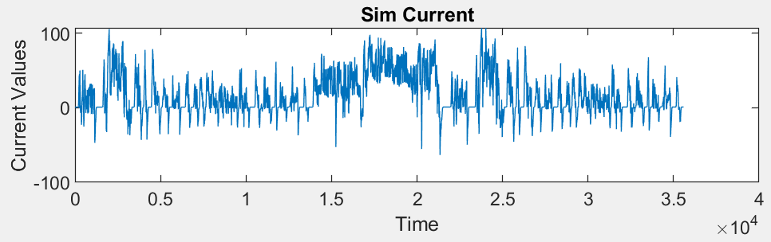
Figure 31. Simulate current result
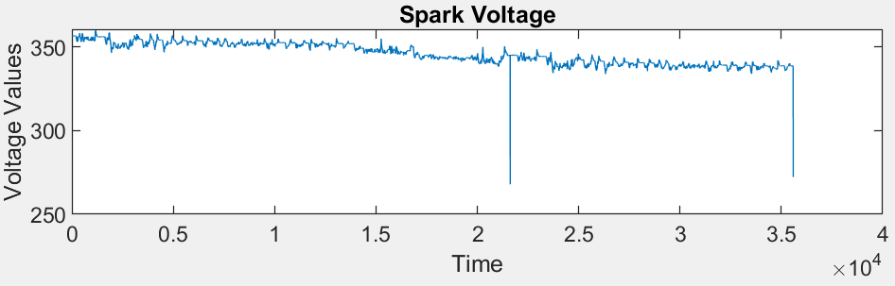
Figure 32. Spark test voltage result
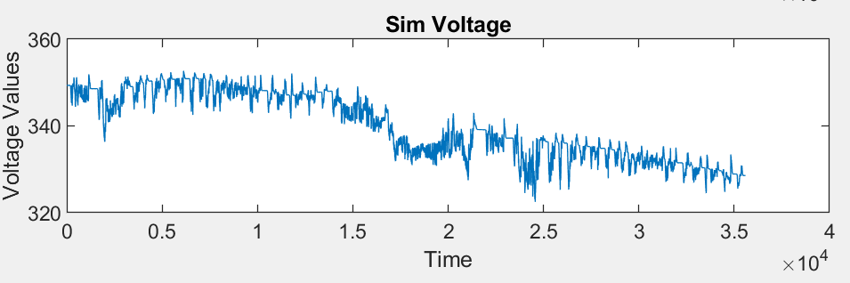
Figure 33. Simulate voltage result
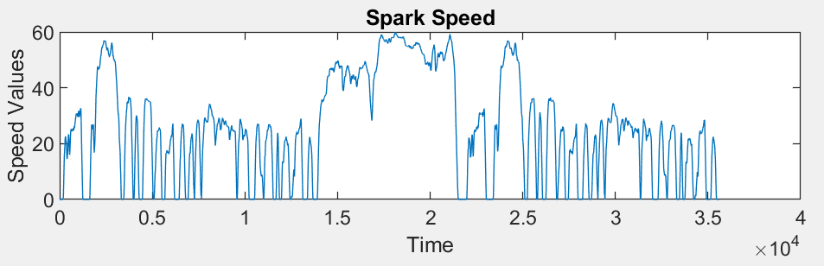
Figure 34. Spark test speed result
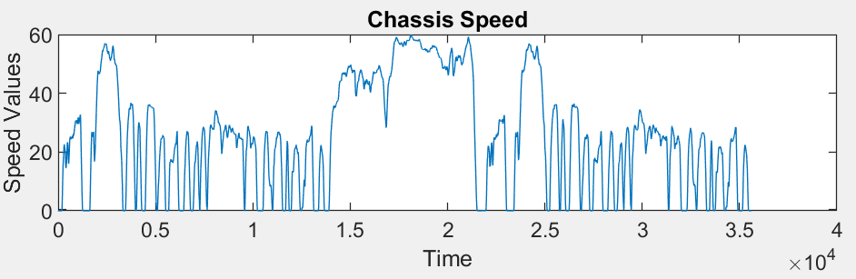
Figure 35. Simulate speed result
I think the reason for the gap between spark test and simulation mainly comes from the following aspects:
- This system does not take into account the effect of outdoor temperature on EV energy efficiency.
- The EV model provided by the test data is Chevrolet, but the efficiency map of the motor module is estimated based on the 2010 Toyota Prius.
- The power consumption of the electronic accessories is an estimate, and in the real situation, the electronic accessories will fluctuate according to the actual outdoor conditions.
- Gear efficiency is set as a fixed value in the model, but this value is affected by torque and gear speed in practice.
- For inertial data from motor and front drive and wheels, all are taken from estimates.

DRIVER MODULE
First, let's focus on the driver module. The function of this module is to compare the actual chassis speed with the drive cycle's required speed and fulfill the test demand, and make the final decision to the control module; therefore, the gap between the chassis speed and drive cycle speed will be balanced.
 | Signal name | Description
Input | Driver cycle | The drive cycle required speed
Input | V_out | The chassis speed
Output | D_out | - Linear speed demand  - Accelerate demand  - Break demand
Table 8. Driver input/output

Linear speed demand
Since the model needs to adjust the driving speed in real time according to the speed of the Drive cycle:
Linear speed demand = The drive cycle required speed.

Accelerate demand & Break demand
In EV driving, there will be three different driving scenarios: the demand speed is equal to the chassis speed, the demand speed is lower than the chassis speed, and the demand speed is higher than the chassis speed. Obviously, in the latter two driving scenarios, acceleration and braking demands are generated.
In addition, factors such as resistance received during EV driving can also cause a loss of forward torque, which in turn affects speed.
Therefore, to analyze whether acceleration or braking is required, it is necessary to comprehensively evaluate the two factors of demand speed difference and torque loss.
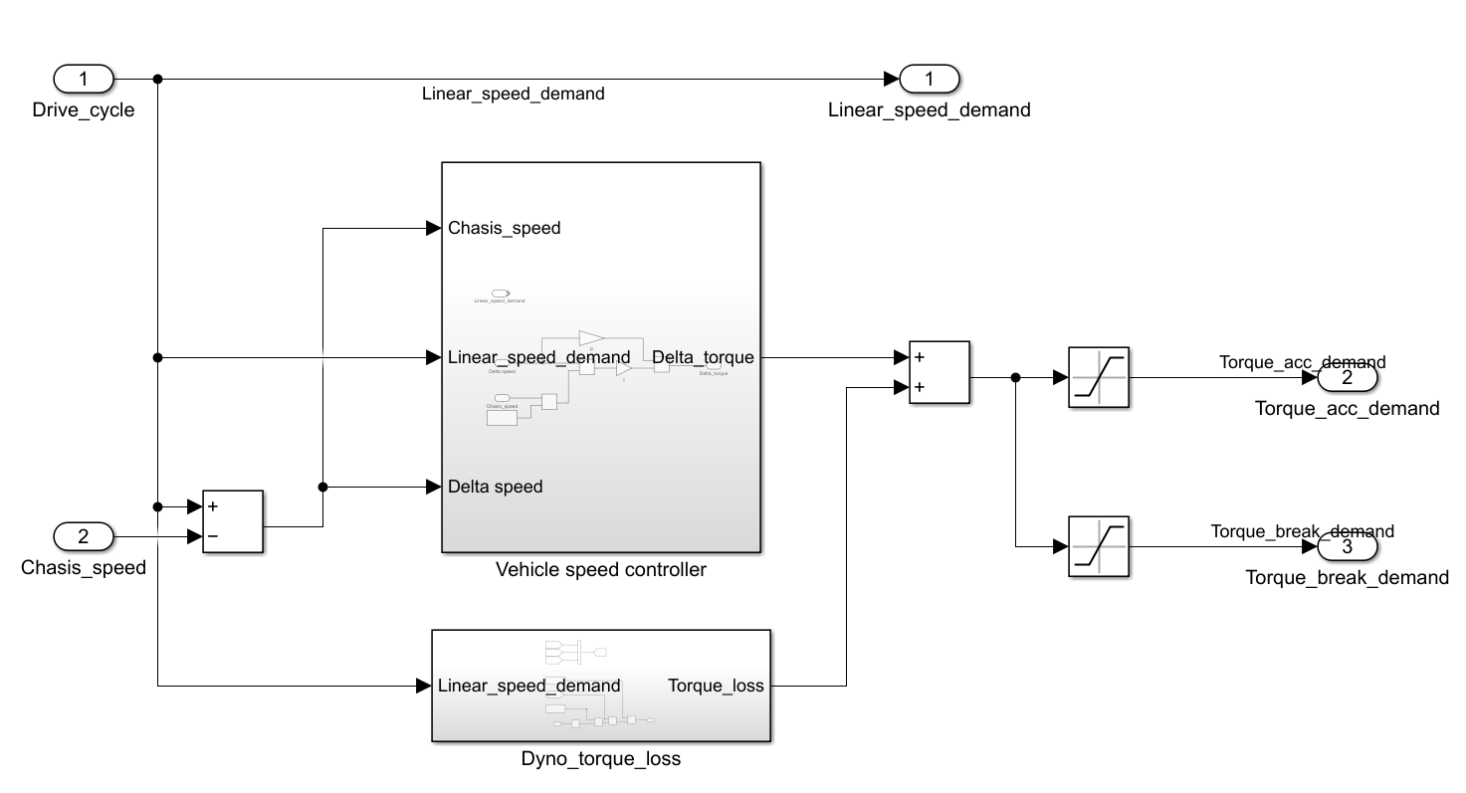
Figure 36. Add the torque required and the torque lost, accelerate if more torque is still needed, brake otherwise

CONTROLLER MODULE
After the driver module process the EV driver cycle speed signal, the outputs transfer of the controller module via V_out bus. In this module, the demands will be analyzed. According to the performance of the motor, the system measures much torque of the motor used for propelling, regeneration break and friction brake.
As the result, the motor torque is equal to propelling torque plus regeneration torque and will be transferred to the vehicle module's motor subsystem, as the torque requirement of the controller. Moreover, the friction brake torque will be transferred to the wheel subsystem in the vehicle module. It helps the calculation of the force of the wheels.
 | Signal name | Description
Input | D_out | - Linear speed demand  - Accelerate demand  - Break demand
Output | C_out | - Motor Torque Command  - Friction Brake Torque Command
Table 9. Controller input/output
First analyze the Propel control of the EV. It should be noted that the torque of the Propel has a certain limit, the required acceleration torque must be lower than the maximum torque of the motor, and the no slip torque. It should also be noted that the signals imported at this stage are all wheel torque, not motor torque.
For the braking part, the system has two forms of regenerative braking and friction braking. When the battery is fully charged, regenerative braking does not operate.
In addition, the reverse torque provided by regenerative braking is sometimes insufficient to meet the braking demand, and the assistance of friction braking is also required.
Hence, the following function is to caculate the torque of the friction break.
𝜏𝑓𝑟𝑖𝑐𝑡𝑖𝑜𝑛_𝑏𝑟𝑎𝑘𝑒 =𝜏𝑑𝑟𝑖𝑣𝑒𝑟_𝑟𝑒𝑞_𝑎𝑡_𝑤ℎ𝑒𝑒𝑙 − 𝜏𝑟𝑒𝑔𝑒𝑛 ×𝑓𝑑
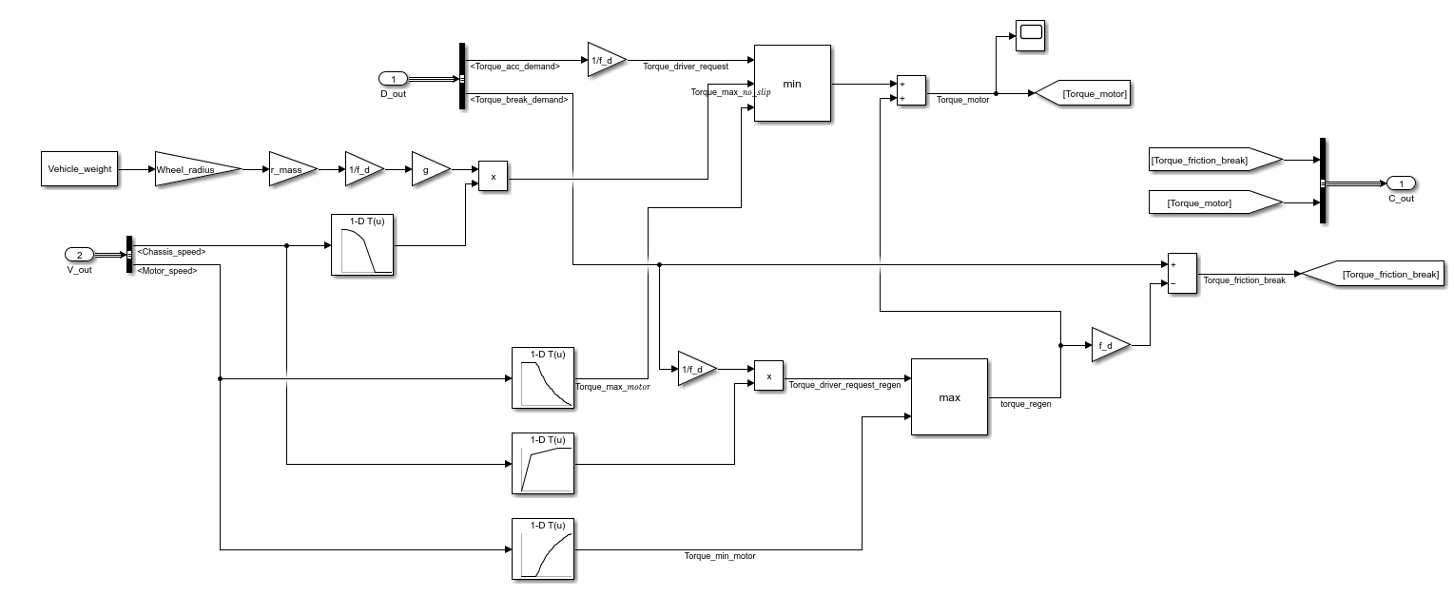
Figure 37. propel and break subsystem

VEHICLE MODULE
The last module is the vehicle module. This module aims to simulate each part of the vehicle (subsystems) and output the information to reflect the model`s operating status.
 | Signal name | Description
Input | C_out | The control signal from controller
Output | V_out | The information signal from subsystems inside vehicle module
Table 10. Vehicle input/output
subsystem name | Description
Battery | Simulating the EV battery provides electrical power to the motor and electrical accessories.
Motor | Simulating the electrical drive motor which follows the command to provide the torque
Electrical_accessories | Simulating the electrical accessories on EV such as air-conditioner and controller which cost the electrical power from the battery.
Final_drive | Simulating the final drive of the EV, transfer the motor rolling by the gear ratio.
Wheel | Simulating the rolling of the wheel, the force of the wheels should be pay attention.
Chassis | Mainly focus on the speed of the chassis.
Table 11. Vehicle subsystems

Chassis
The chassis, as the meaning is the body of the vehicle. The main function of the subsystem is to transfer the force from the wheels to the line speed of the vehicle. The line speed of the vehicle is going to feedback to the driver module, for the linear speed is compared with the driver cycle speed during the model operation.
 | Signal name | Description
Input | Force_mass | - Force from the wheel (N)  - Powertrain inertia equivalent mass (kg)  - Road grade (radians)
Output | Chassis_speed | Linear speed of the vehicle (m/s)
Table 12. Chassis input/output
Since the input signal is the force transmitted by the wheel, as long as the force analysis of the vehicle is carried out, the acceleration of the vehicle can be obtained by deducting factors such as air resistance and road resistance. By integrating the acceleration, it is not difficult to obtain the linear velocity of the vehicle body.

Wheel
The wheel obtains the mechanical torque transmission from the front drive through the bearing. The main purpose of this module is to convert the torque into the rotational speed of the wheel and the corresponding propulsion force.
 | Signal name | Description
Input | Control | Torque of the friction break
Input | Torque/inertia | Torque and inertia from the front drive (N·m/kg/ kg·m²)
Input | Chassis_speed | Linear speed of the vehicle (m/s)
Output | Force_mass | - Force from the wheel (N)  - Powertrain inertia equivalent mass (kg)  - Road grade (radians)
Output | Wheel_speed | Rotational speed of the wheels (rad/s)
Table 13. Wheel input/output
At this stage, it is mainly necessary to distinguish between linear speed and rotational speed. When calculating propulsion through torque, it is necessary to consider the deformation of the wheel radius due to gravity.

Final drive
The electric motor powers the EV through high-speed rotation, and the role of the front drive is the bridge between speed and torque to ensure that the wheels can rotate normally. The final drive is a fixed gear ratio, and the last gear before power is sent to the wheels. It reduces speed and increases torque going to the wheels.
 | Signal name | Description
Input | Wheel_speed | Rotational speed of the wheels (rad/s)
Input | Torque/inertia | Torque and inertia from the motor (N·m/kg/ kg·m²)
Output | Torque/inertia | Torque and inertia to the wheel (N·m/kg/ kg·m²)
Output | fd_speed | Rotational speed of the gear(rad/s)
Table 14. Final drive input/output
When the input torque is greater than 0, the torque is multiplied by the gear ratio because of the power transmission losses. But when the torque is less than 0, this represents the regenerative braking mode. The negative torque is from the motor, gear, and transmission, so it needs to be divided by the gear ratio.

Motor
The subsystem of the motor is the key element of the model. It provides the torque by spinning the rotor, and the speed of spinning can be adjusted by the frequency and voltage of the electrical power. The motor has two operation modes: proportion and regenerative break. The system has to figure out how to swift between these two modes. Therefore, a sign block is needed to check the torque command from the controller. If the torque command is greater than 0, the motor operates the proportion. Otherwise, operating regenerative brake.
Another important parameter is the efficiency of the motor/inverter, this part should follow the efficiency map.
 | Signal name | Description
Input | Torque_command | The torque required by the controller(N·m)
Input | Voltage | The battery terminal voltage(V)
Input | fd_speed | Rotational speed of the geat(rad/s)
Output | Torque/inertia | Torque and inertia from the motor (N·m/kg/ kg·m²)
Output | Current | The motor costed electrical power(A)
Table 15. Motor input/output

Electrical accessories
 | Signal name | Description
Input | Voltage | The battery terminal voltage(V)
Output | Current | The electrical accessories costed electrical power(A)
Table 16. Electrical accessories input/output
In addition to the drive system, the EV also has electronic accessories, such as air conditioners and Bluetooth speakers. They also consume the EV's power, even if the EV's speed is 0, the battery power is still draining.
In this project, the energy consumption calculation method of electronic accessories is to estimate the power consumption of electronic accessories through the data when Spark data EV is stopped, and then calculate the current consumption according to the electric power theorem.

Battery
 | Signal name | Description
Input | Current | The electrical power costed by electrical accessories and motor(A)
Output | Voltage | The battery terminal voltage(V)
Table 17. Electrical accessories input/output
When the current demand of the motor and electronic accessories is input to the battery module, the system integrates the current (A) based on time to obtain the power consumption (Ah), the fluctuating SOC value.
Depending on the battery characteristics, the output voltage varies according to the SOC value. At the same time, the terminal voltage will also change due to the impedance change inside the battery. Therefore, to calculate the terminal voltage, it is necessary to extract the open-circuit voltage of the battery when the battery current approaches 0 according to the data of the Spark dyno test. At the same time, according to the data, when the battery is charged and discharged, the battery's internal impedance is obtained.

